

**TASK**

**Exploratory Data Analysis on the US Arrests Dataset**

[](http://www.hyperiondev.com/portal/)

**Introduction**

Summary of the data set

This dataset consists of the number of arrests that were made in the USA. The dataset shows the city in which arrests were made and the type of crime that was committed.

**DATA CLEANING**

The methods used to clean the data include finding duplicates (no duplicates were found), changing some of the column's datatypes to more relevant data types (‘City’ column), and making sure that the city names are unique in other to avoid repetitions.

**MISSING DATA**

There was no missing data in this dataset.

**DATA STORIES AND VISUALISATIONS**

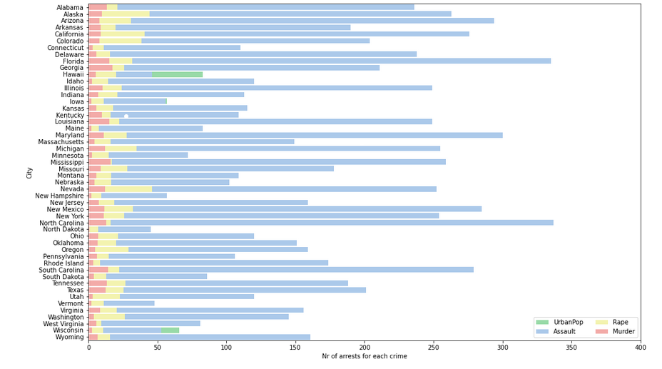

New York City and Florida City have the highest Assault arrests.

Nevada, Alaska, and California have the highest Rape arrests.

Georgia and Mississippi have the highest Murder arrests.

Hawahii and Wisconsin have the highest UrbanPop arrests.

Overall, Assault arrests are the highest.

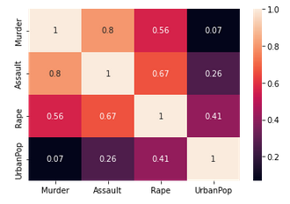

**Murder and Assault have the strongest correlation and Murder and UrbanPop have the weakest.**

# ENSURE THIS DOCUMENT IS NEAT AND ADD IT TO YOUR PORTFOLIO

**THIS REPORT WAS WRITTEN BY : YOUR NAME**

